IMPLEMENTING WEB

APPLICATION

|  |  |
| --- | --- |
| Date | 30 Oct 2022 |
| Team ID | PNT2022TMID24156 |
| Project Name | CUSTOMER CARE REGISTRY |

CREATING UI TO INTERACT WITH APPLICATION:

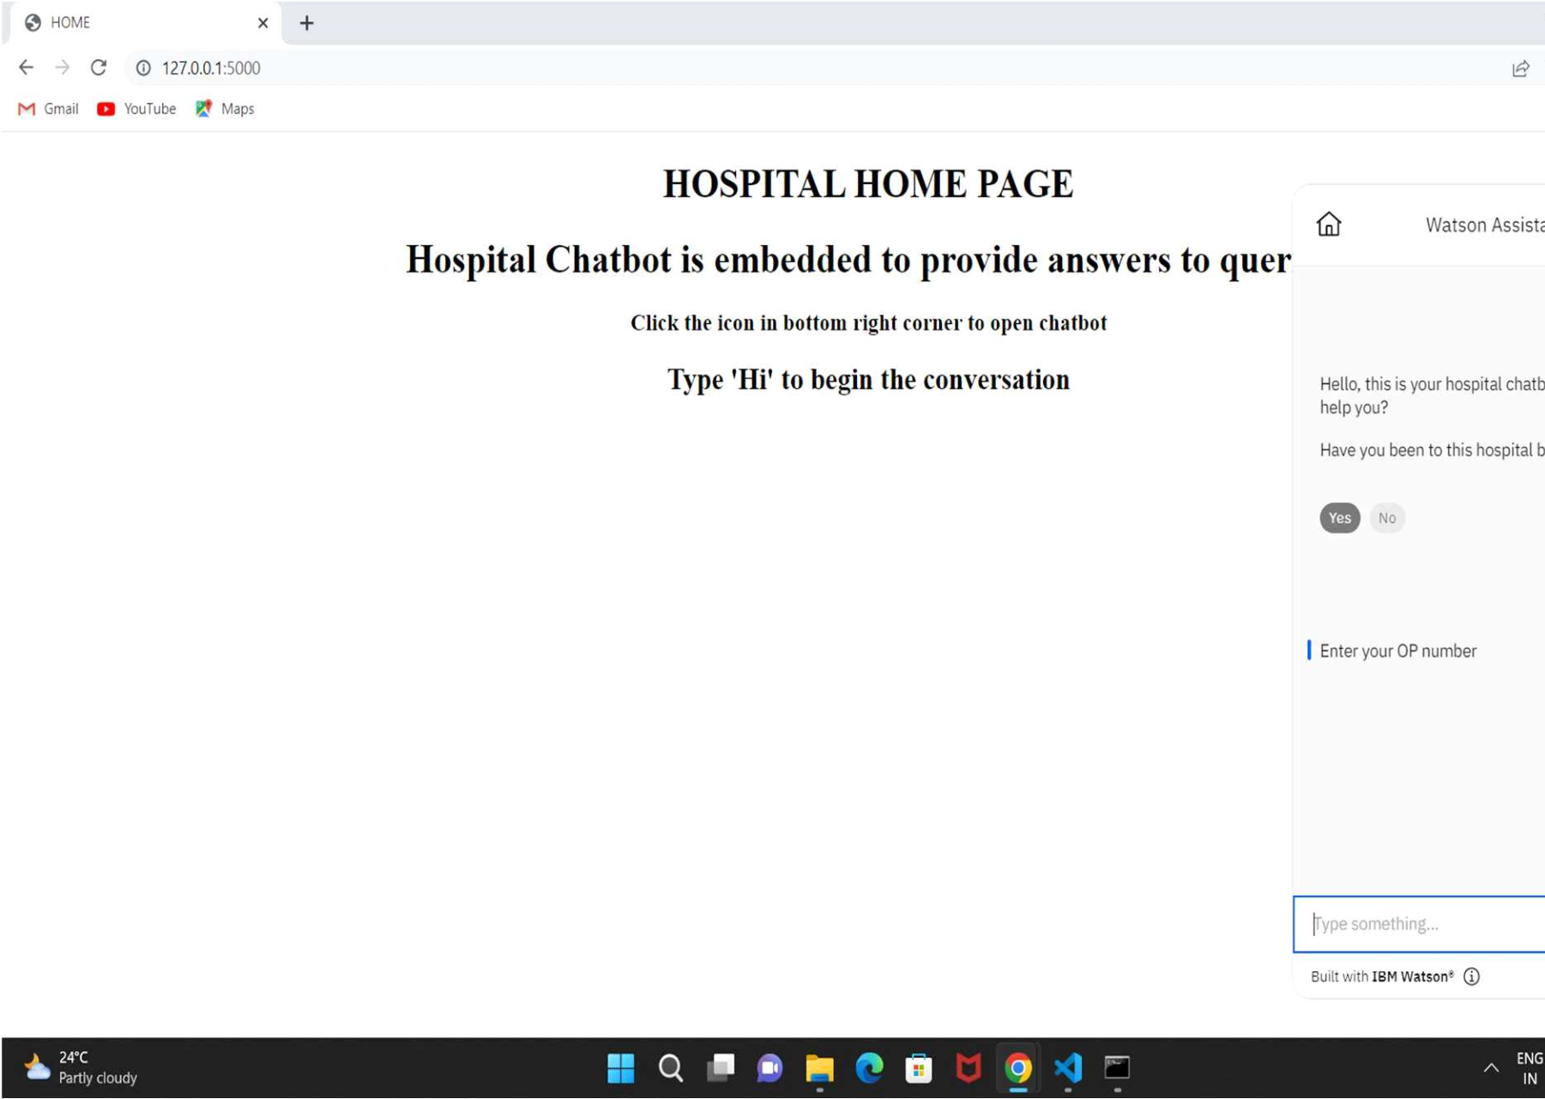

1